COLLEGE VOTING SYSTEM
ABSTRACT
College voting System would have Candidate registration, document verification, auto-generated User ID and pass for candidate and Voters. Admin Login which will be handled by Election Commission. Candidate Login which will be handled By Candidate, Voters will get Unique ID and Password, using which they can vote for a Candidate only once per Election. Admin can enter the login and create candidate and voter details, once the voter ID has generated, they can login and vote to the candidate. The project is beneficial for Election Commission, Voters as the can get to know the candidate background and choose wisely, and even for Candidate. The software system allows the Candidate to login in to their profiles and upload all their details including their previous milestone onto the system.
The college voting system is highly developed and the college voting system can be replaced by accurately and directly voting and immediate results. The college voting system is done by the internet so it can be called the Internet Voting.

SYSTEM SPECIFICATION
HARDWARE SPECFICATION:
- System : Pentium IV 2.4 GHz.
- Hard Disk : 180 GB.
- Floppy Drive : 1.44 Mb.
- Ram : 8 GB.

SOFTWARE SPECIFICATION:

- Operating system : Windows 7,8.
- Front End : JAVA
- Back End : SQL Server 2005

EXISTING SYSTEM:
The voter gets a blank ballot and use a pen or a marker to indicate he want to vote for which candidate. Hand-counted ballots is a time and labor consuming process, but it is easy to manufacture paper ballots and the ballots can be retained for verifying, this type is still the most common way to vote.
DISADVANTAGES:
- Chances of hacking candidate or voter’s account.
- Every voter does not have pc or net connection, so voters can even go in polling booth and vote there.

PROPOSED SYSTEM:

In this system voter can voting their candidate via college voting system. With the help of that system, we can vote easily. User can’t vote more than one time. In this system helps to counting the vote very easy.
ADVANTAGES OF THE PROPOSED SYSTEM:

- Fast and easy way of conducting Election.
- Voters can view background of each Candidate.
- Candidate can present themselves against voters.
- Admin can verify the documents and details of Candidate.
- System Generated Unique ID and Password gives more Secure Logins

MODULES:
MODULES DESCRIPTION:
Voter Registration
Voters are created by admin, once voters are created, they will get unique username and password. The voter’s can able to login via this application and update his/her profile details. Voter can’t add themselves.
Candidate Registration
Candidate’s are created by admin, once candidates are created they will displayed in the voting screen. Those details will be displayed in the election result as well.
Candidate & Voter Details:
This module contains provide the all information about the voter’s and candidates. These values have been collected from the voter and candidate table.
Pooling vote
Voter can pool their vote in this module. Once voter pooling their vote can’t vote more than one time. Voter select his favorite voter and pooling their vote
Election Result
Election result will be declared after the election will completed. Which is the main module for finding the winner. Rank wise we can displayed the winner candidates

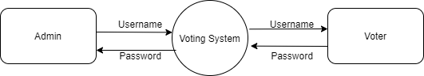

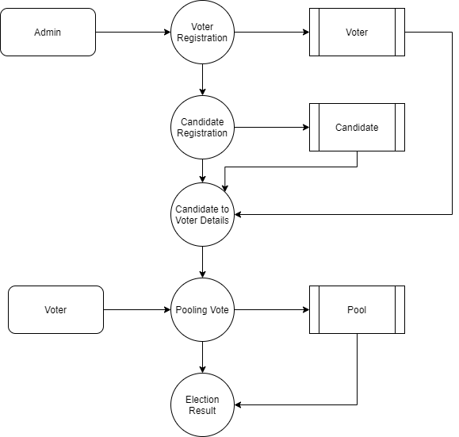

TABLE NAME: ADMIN
FIELD | DATA TYPE | SIZE | CONSTRAINT
admin id | Int | 10 | Primary key
Admin name | Varchar | 30 | Not null
Admin mobile | Int | 10 | Not null
Username | Varchar | 20 | Not null
Password | Varchar | 20 | Not null
TABLE NAME: VOTER
FIELD | DATA TYPE | SIZE | CONSTRAINT
Voter id | Int | 10 | Primary key
Voter type | Varchar | 20 | Not null
Email | Varchar | 20 | Not null
Password | Varchar | 20 | Not null
First name | Varchar | 20 | Not null
Last name | Varchar | 20 | Not null
Mobile number | Int | 10 | Not null
Address | Varchar | 30 | Not null

TABLE NAME: CANDIDATES
FIELD | DATA TYPE | SIZE | CONSTRAINT
Candidate id | Int | 10 | Primary key
Post | Varchar | 20 | Not null
First name | Varchar | 20 | Not null
Last name | Varchar | 20 | Not null
Mobile | Int | 10 | Not null
Email | Varchar | 20 | Not null
Address | Varchar | 30 | Not null
TABLE NAME: POOL
FIELD | DATA TYPE | SIZE | CONSTRAINT
Pool id | Int | 10 | Primary key
Candidate id | Int | 10 | Foreign key
Voter id | Int | 10 | Foreign key
Post id | Int | 10 | Foreign key

